PRESS RELEASE
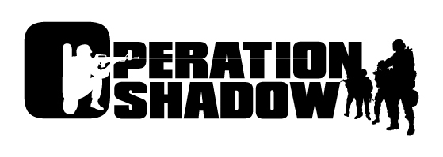
Nokia announces Operation Shadow for the N-GageTM mobile game deck.

December 8, 2003 – Nokia today announced Operation Shadow, its second own published title for the N-Gage game deck. Operation Shadow is a war themed 3D action adventure that immerses gamers into the world of heavy combat action, lightning strikes and the latest military equipment. With multiplayer support for up to 4 players via Bluetooth wireless technology, Operation Shadow allows for fast-paced and action-packed competitive game play.

“We are thrilled to announce Nokia’s second own published game title,” said Pasi Pölönen, Director of Game Publishing, Entertainment and Media Business Unit, Nokia Mobile Phones. “Operation Shadow is a great example of how Nokia titles will be known for their innovative use of the mobile multiplayer features of the N-Gage platform. Imagine competing on the death match battlefield, forming a team with your friends and taking each other on. Each player’s team can exploit the tactical advantages of the various vehicles as they battle for supremacy and bragging rights.”

As well as fighting on foot, aspiring heroes can choose from a selection of vehicles to fight against the enemy including, helicopters, tanks and hummers. Players will be able to use multiple vehicles in every mission. Thanks to the game’s developed AI, enemies will fight with increasing sophistication, taking cover and working together to attack and defend, as players progress through the game.

Operation Shadow is expected to be available on the N-Gage game deck in the first half of 2004. Operation Shadow is being developed by Torus Games, a leading game developer based in Melbourne, Australia.

“We are delighted to be working with Nokia on Operation Shadow,” said Bill McIntosh, Managing Director of Torus Games. “The N-Gage game deck has the technical capabilities to push the boundaries of mobile gaming to a new and exciting level.”

About N-Gage
The N-Gage game deck is an innovative mobile device that is creating an entirely new market for the games industry. Built for active and hardcore gamers, the N-Gage platform is the first mobile and connected game deck to feature online high-quality 3D multiplayer gameplay over Bluetooth wireless technology and GPRS. The N-Gage device also offers unique online games services as well as a comprehensive and growing games catalogue from the leading game publishers. Nokia is the world leader in mobile communications. Nokia and N-Gage are trademarks or registered trademarks of Nokia Corporation.
About Torus Games
Torus Games is an independent developer of video games based in Melbourne, Australia. Torus has been developing video games since 1994 and employs over 50 staff. For more information please visit: http://www.torus.com.au

Further information, please contact:

For Media only

Nokia Corporation
Nokia Mobile Phones
Communications
Tel: +358 7180 45667
E-mail: press.office@nokia.com

Nokia Communications, Americas
Tel: +1 972 894 4573
E-mail: n-gage.media@nokia.com

Nokia Communications, Asia Pacific
Tel: +65 6723 2323
E-mail: communications.apac@nokia.com

www.n-gage.com/press
www.nokia.com

Copyright © 2003 Nokia. All rights reserved. Nokia and N-Gage are trademarks or registered trademarks of Nokia Corporation. Bluetooth is a registered trademark of Bluetooth SIG, Inc. Some features and services are dependent on the network, supported digital content formats, the compatibility of other devices and applications, and other factors. Please refer to the user guide for complete information.

